**CNS TUTORIAL TASK 2: ANIMAL TOOL**

**Name: ARBAZ AHMED**

**USN: 1BM19CS401**

ANIMAL is a general-purpose animation tool that provides visualizations for a variety of algorithms used in Backtracking, Graph, Cryptography, Sorting, Hashing, etc and is implemented in Java.

For example, I have explored Dijkstra Alg Visualization

Navigate to: File-->Generator-->Graph-->Dijkstra Algorithm

Tab will give an option to add/delete/edit values for input.

* As we click on Start, a new animation window opens where the code is traced for the given input.
* Before the tracing begins, the description of the algorithm is shown and after the animation is complete time complexity is analysed.

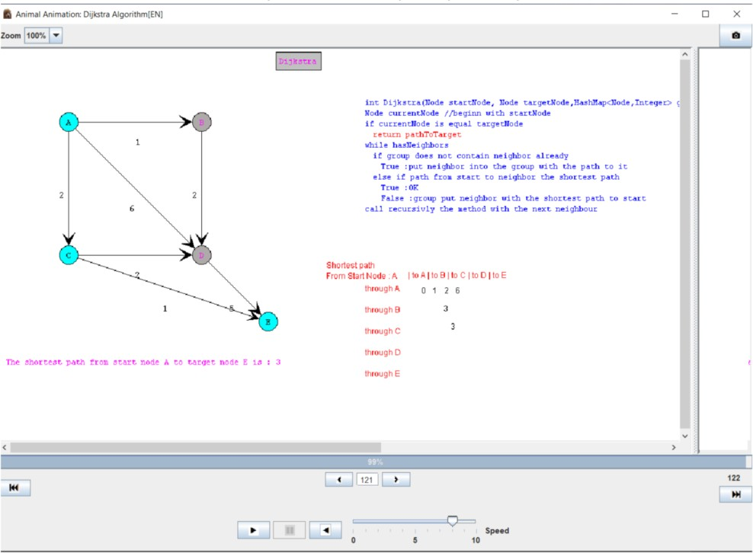

Vigenère Cipher:

It uses polyalphabetic substitution and it has linear complexity. The key is repeated to match the plaintext length and spaces in between are also considered. The letters of the plaintext (in row) are paired with that of key (in column) in the Vigenère square to generate ciphertext.

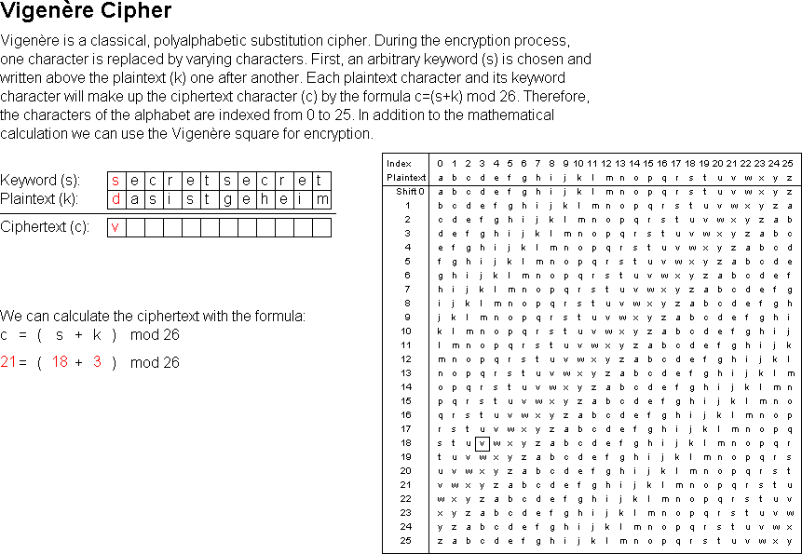

* Using the default plaintext and key:

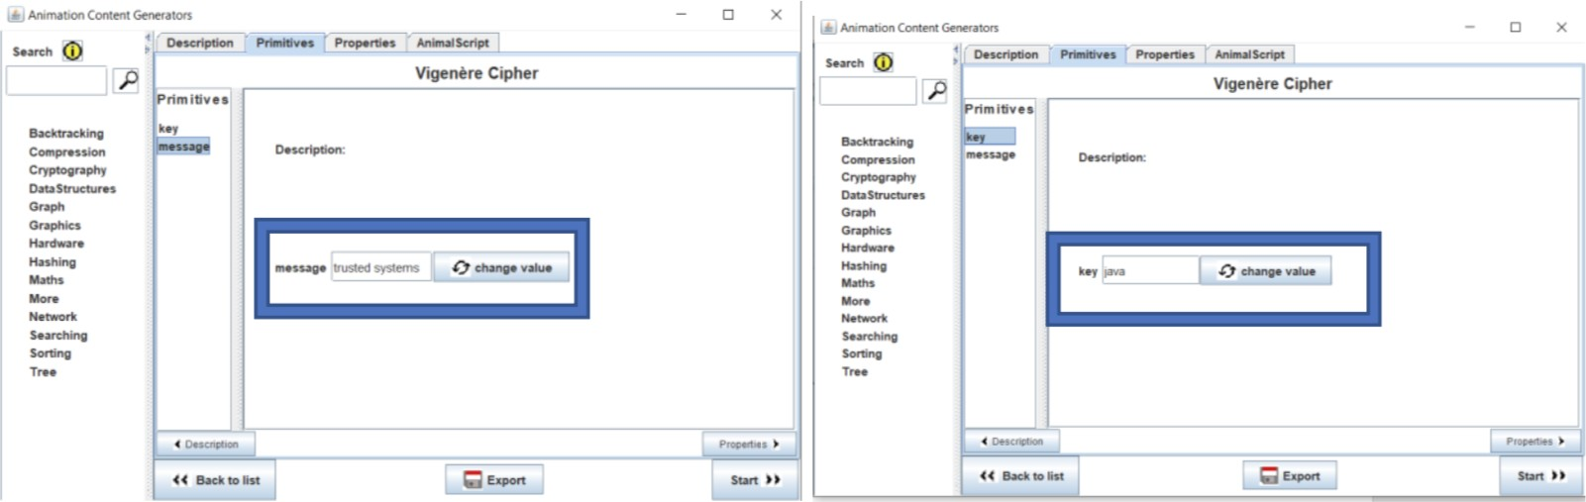

KEYWORD: JAVA

PLAINTEXT: TRUSTED SYSTEMS

KEY: JAVAJAVAJAVAJAV

CIPHERTEXT: CRPSCEY BYNTNMN

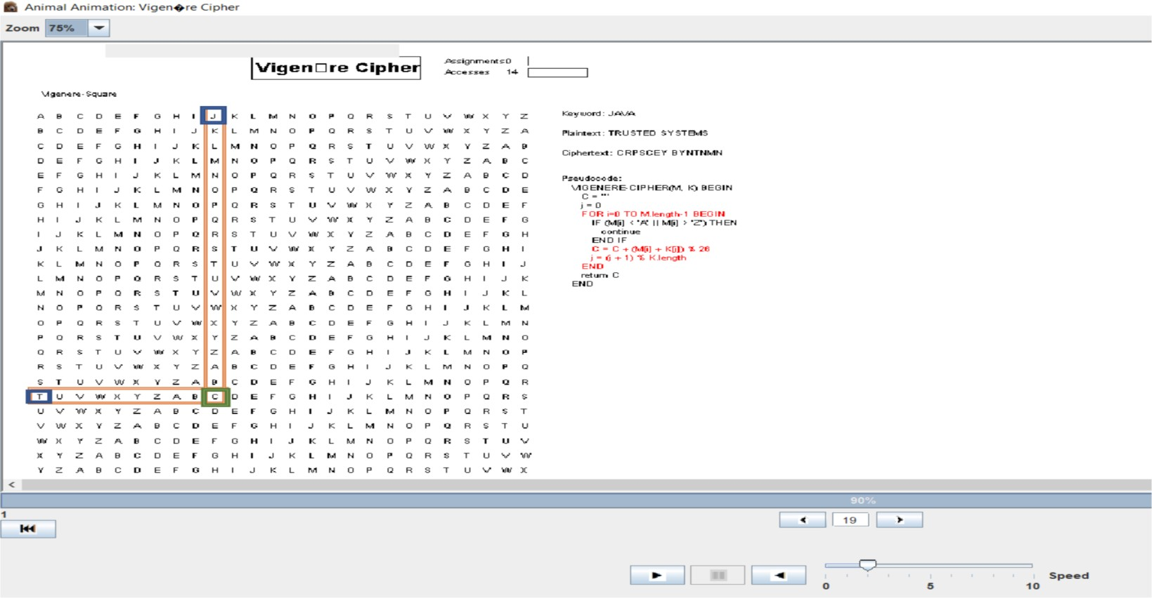

* Changing the plaintext and keeping the same key:

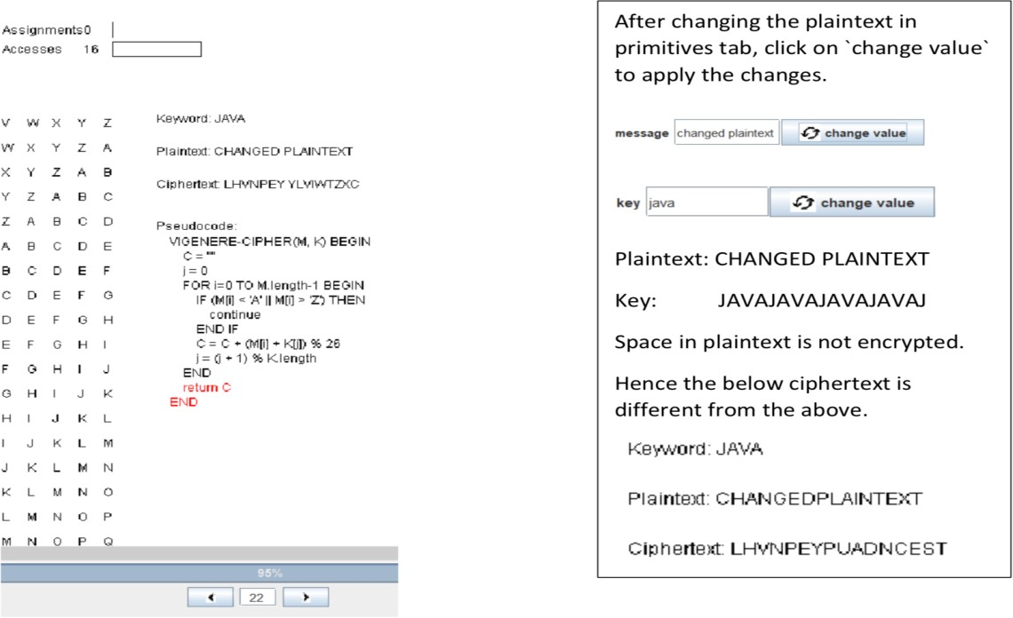

* Changing both the plaintext and the key:

